**PRACTICAL - 6**

**AIM:** Demonstrate the static and dynamic configuration of NAT using cisco packet tracer

**THEORY:**

**NAT**

**What is Network Address Translation (NAT)?**

* **NAT (Network Address Translation) is a process of changing the source and destination IP addresses and ports.**
* **Address translation reduces the need for IPv4 public addresses and hides private network address ranges.**
* **The process is usually done by routers or firewalls.**

**How does it work?**

* **It is suitable only for small network.**
* **If a link fails it cannot reroute the traffic.**

**There are three types of address translation.**

* **Static NAT – translates one private IP address to a public one. The public IP address is always the same.**
* **Dynamic NAT – private IP addresses are mapped to the pool of public IP addresses.**
* **Port Address Translation (PAT)– one public IP address is used for all internal devices, but a different port is assigned to each private IP address. Also known as NAT Overload.**

**STATIC CONFIGURATION OF NAT**

**TOPOLOGY:**

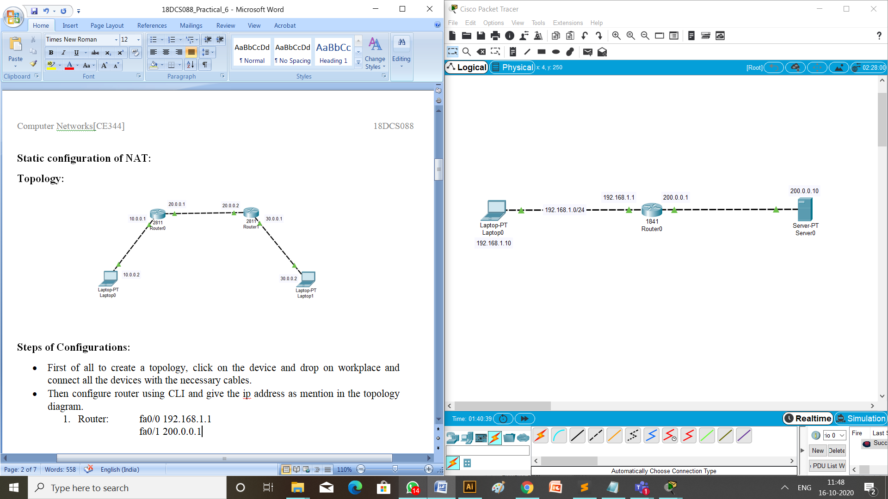

**STEPS OF CONFIGURATION**

**Provide IP address to all the Routers**

1. **First of all to create a topology, click on the device and drop on workplace and connect all the devices with the necessary cables.**
2. **Then configure router using CLI and give the ip address as mention in the topology diagram.**
3. Router: fa0/0 192.168.1.1

fa0/1 200.0.0.1

1. **Provide ip address and default gateway to the laptop.**
2. Laptop: ip address is 192.168.1.10

default gateway is 200.0.0.1

1. **Provide ip address and default gateway to the server.**
2. Server: ip address is 200.0.0.10

default gateway is 200.0.0.1

1. **Configuration of Static NAT on router 0,**

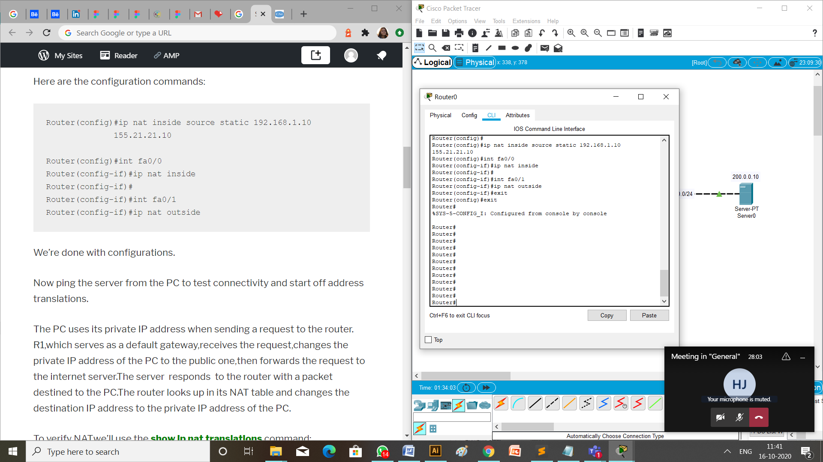

1. **Verify Static NAT configuration.**

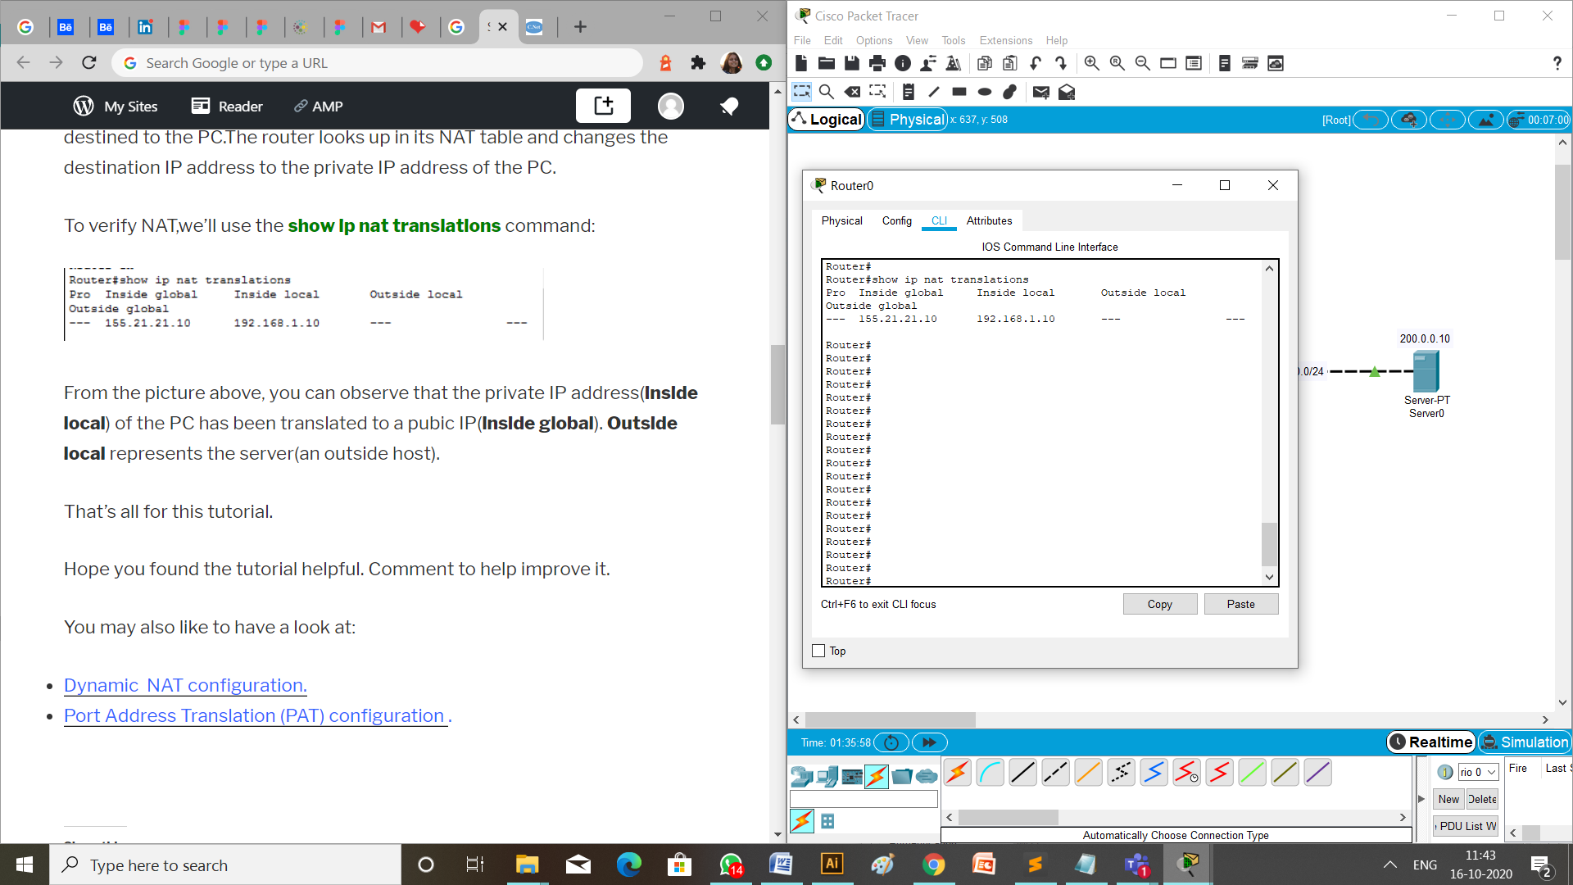

**CHECK NETWORK TOPOLOG**

We can check if the connection is working properly by two ways:

1. **MESSAGE PASSING**

To check the connections are working properly or not drop one package on a Laptop and receive it from the Server.

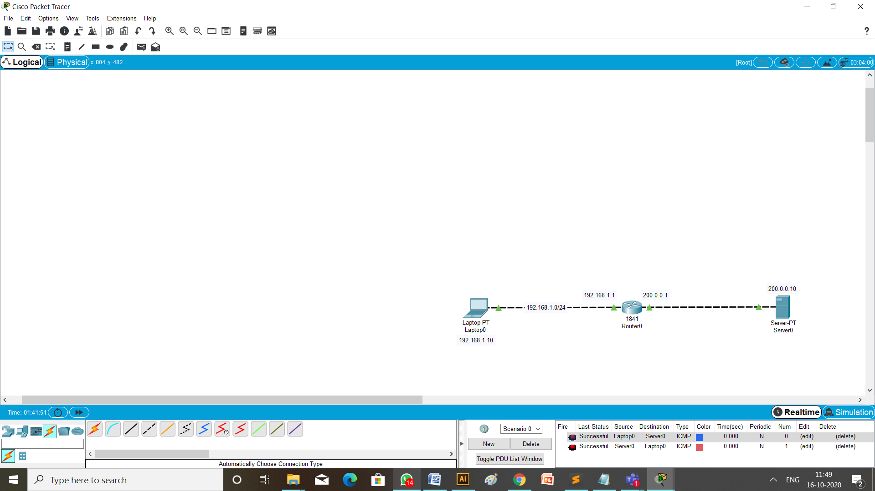

1. CHECKING NETWORK TOPOLOGY USING **PING** COMMAND

Write a command ping 200.0.0.10 (ip address of the Server) from the command prompt of Laptop having ip address 192.168.1.10 (the source Laptop).

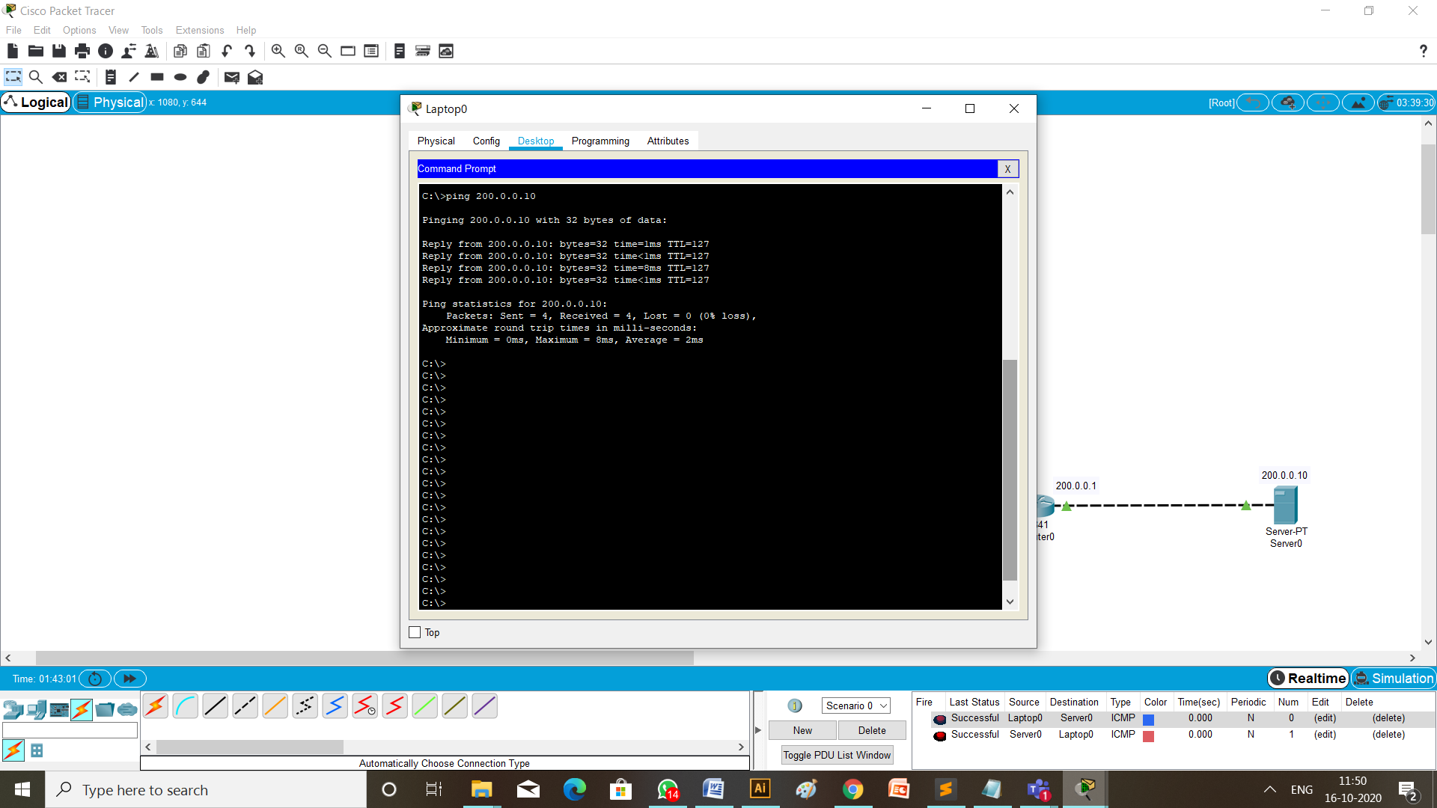

**DYNAMIC CONFIGURATION OF NAT**

**TOPOLOGY:**

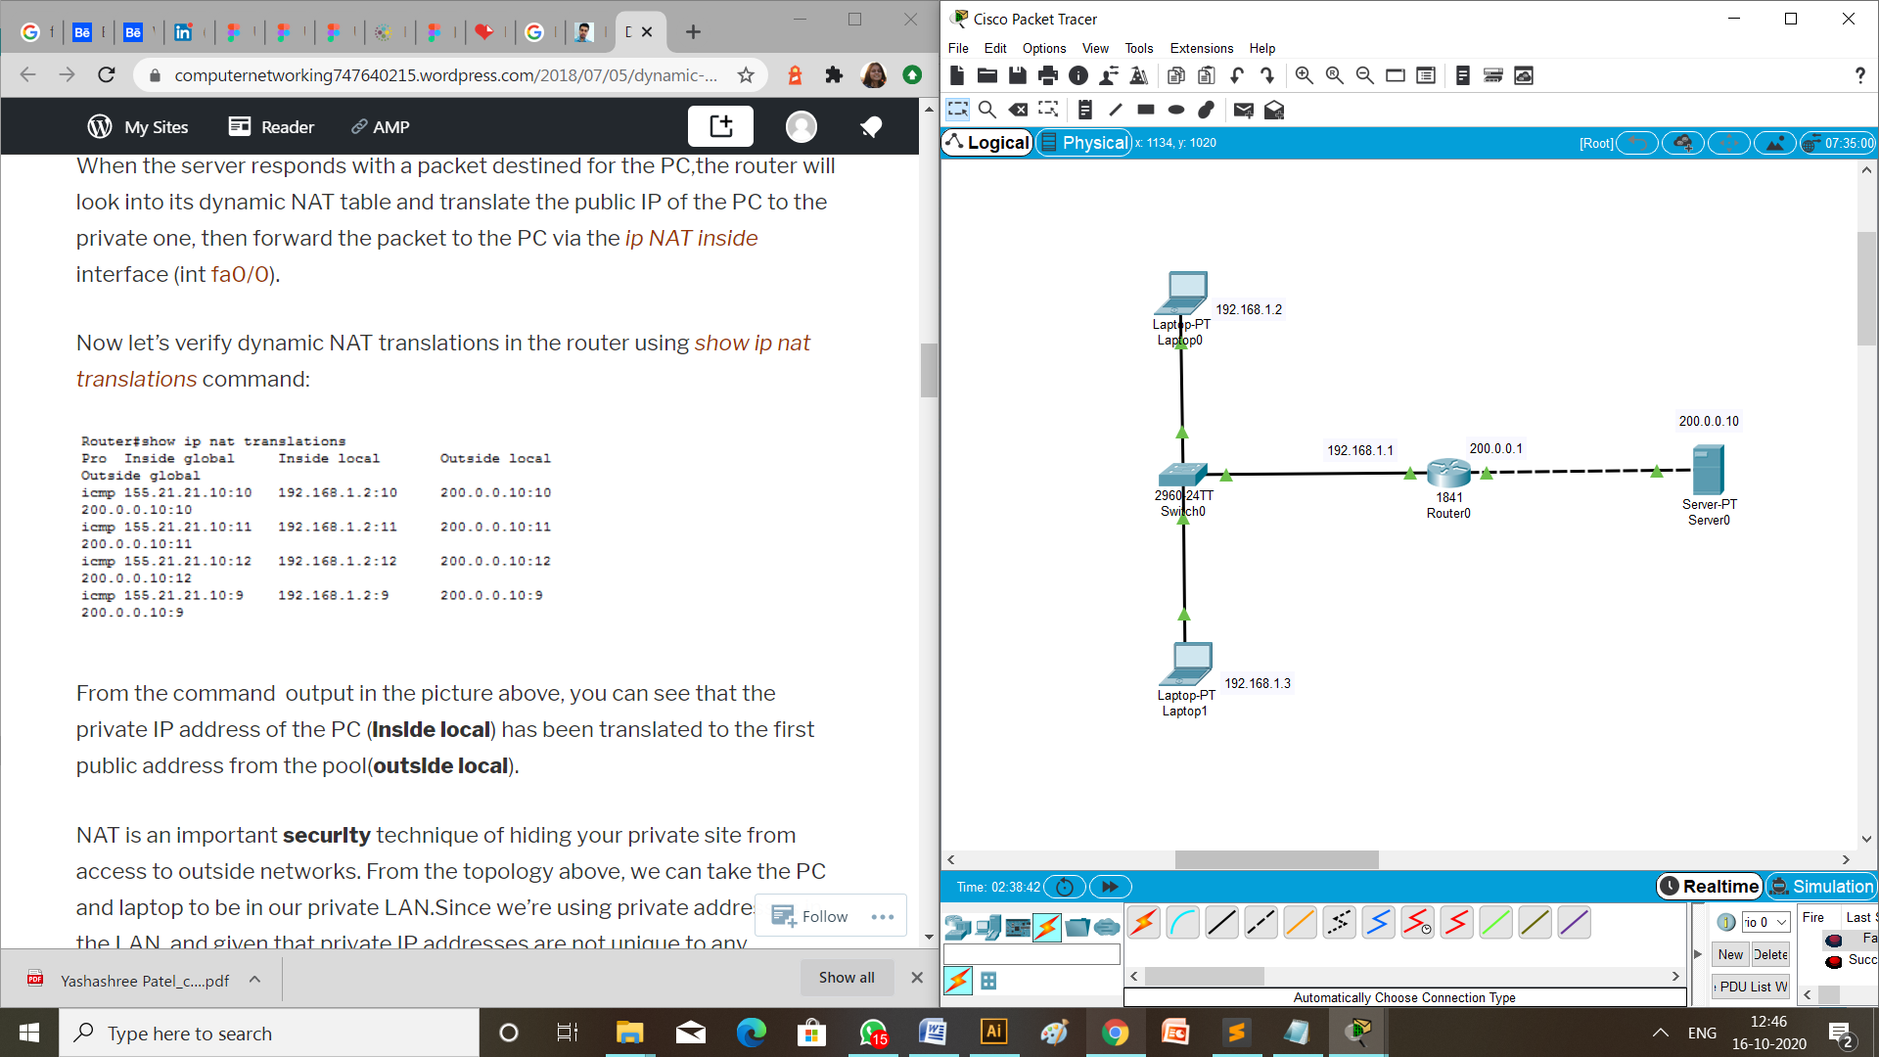

**STEPS OF CONFIGURATION**

**Provide IP address to all the Routers**

1. **First of all to create a topology, click on the device and drop on workplace and connect all the devices with the necessary cables.**
2. **Then configure router using CLI and give the ip address as mention in the topology diagram.**
3. Router: fa0/0 192.168.1.1

fa0/1 200.0.0.1

1. **Provide ip address and default gateway to the laptop.**
2. Laptop 1: ip address is 192.168.1.2

default gateway is 200.0.0.1

1. Laptop 2: ip address is 192.168.1.3

default gateway is 200.0.0.1

1. **Provide ip address and default gateway to the server.**
2. Server: ip address is 200.0.0.10

default gateway is 200.0.0.1

1. **Configuration of Static NAT on router 0,**

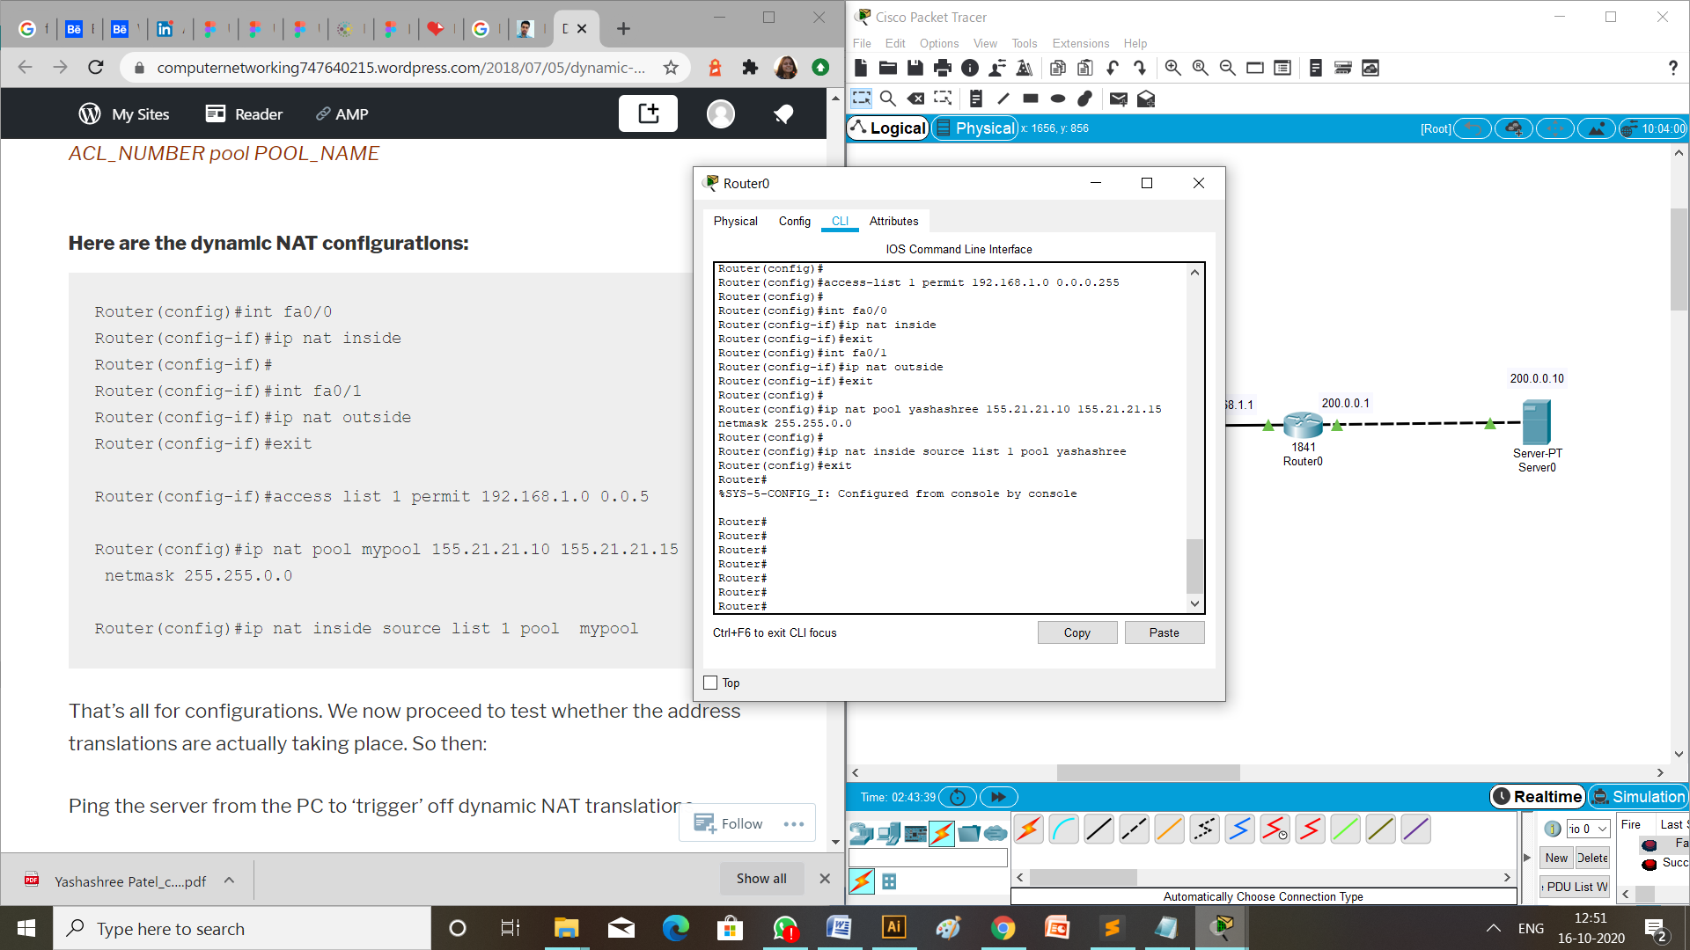

1. **Verify Static NAT configuration.**

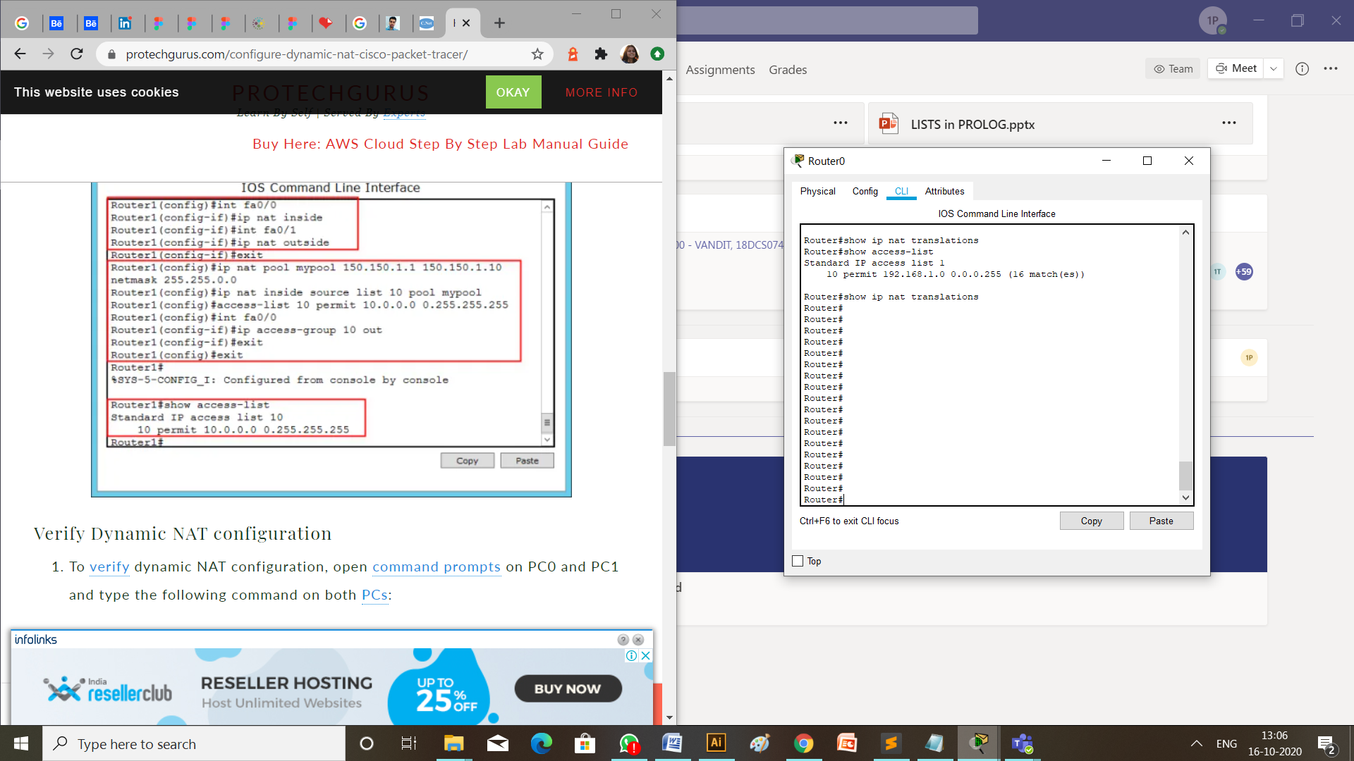

**CHECK NETWORK TOPOLOG**

We can check if the connection is working properly by two ways:

1. **MESSAGE PASSING**

To check the connections are working properly or not drop the packets from laptop to server.

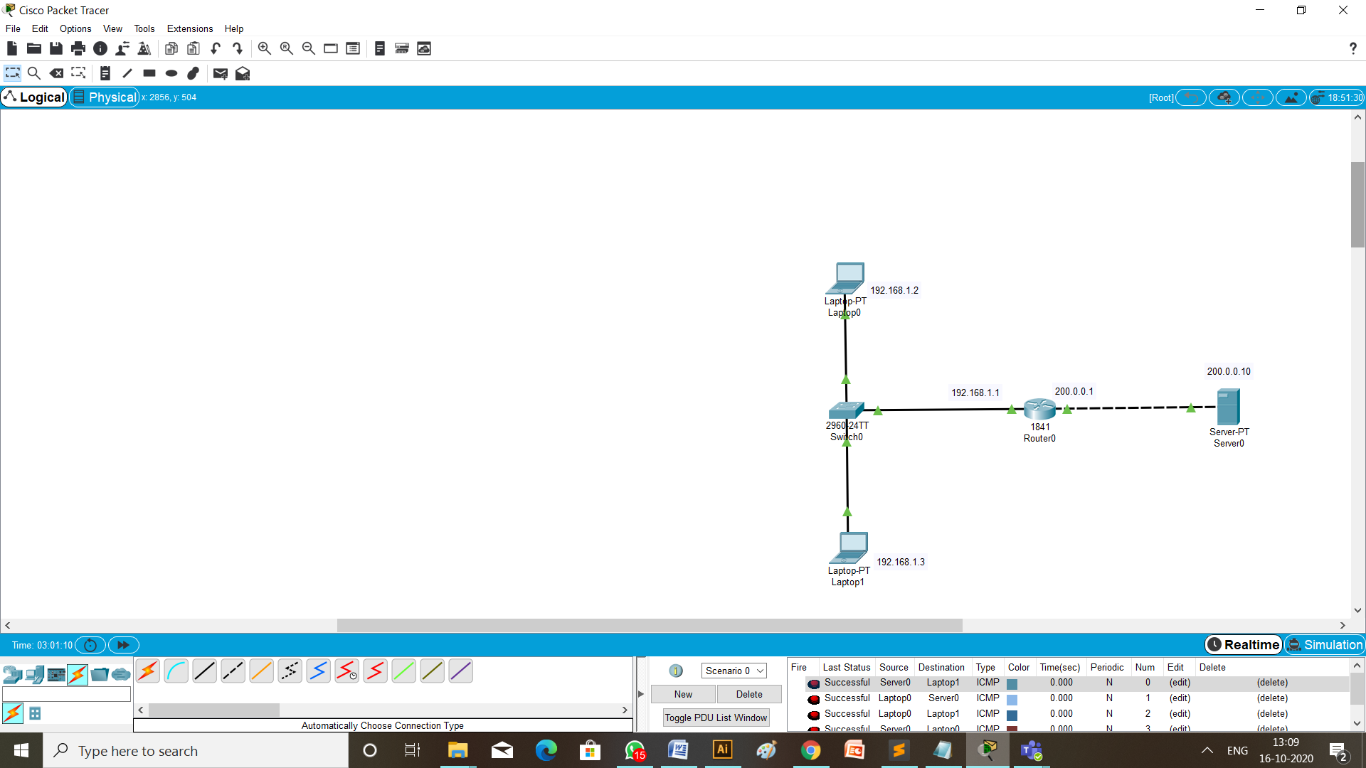

1. CHECKING NETWORK TOPOLOGY USING **PING** COMMAND

Write a command ping 200.0.0.10 (ip address of the Server) from the command prompt of Laptop having ip address 192.168.1.2 (the source Laptop 0).

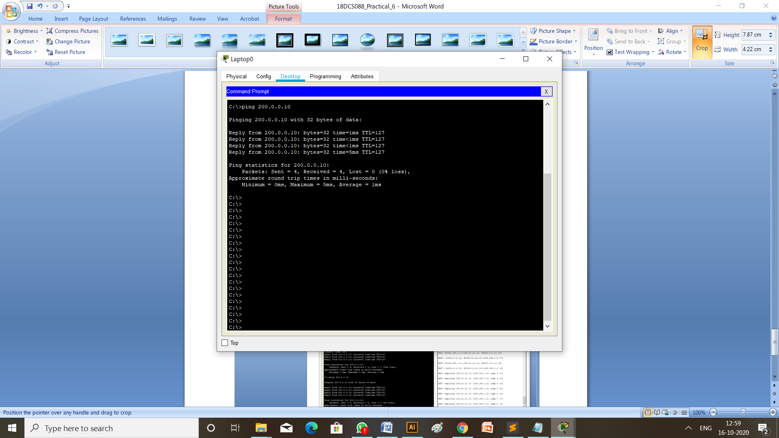

Just when ping run *<debug ip nat>* command on router:

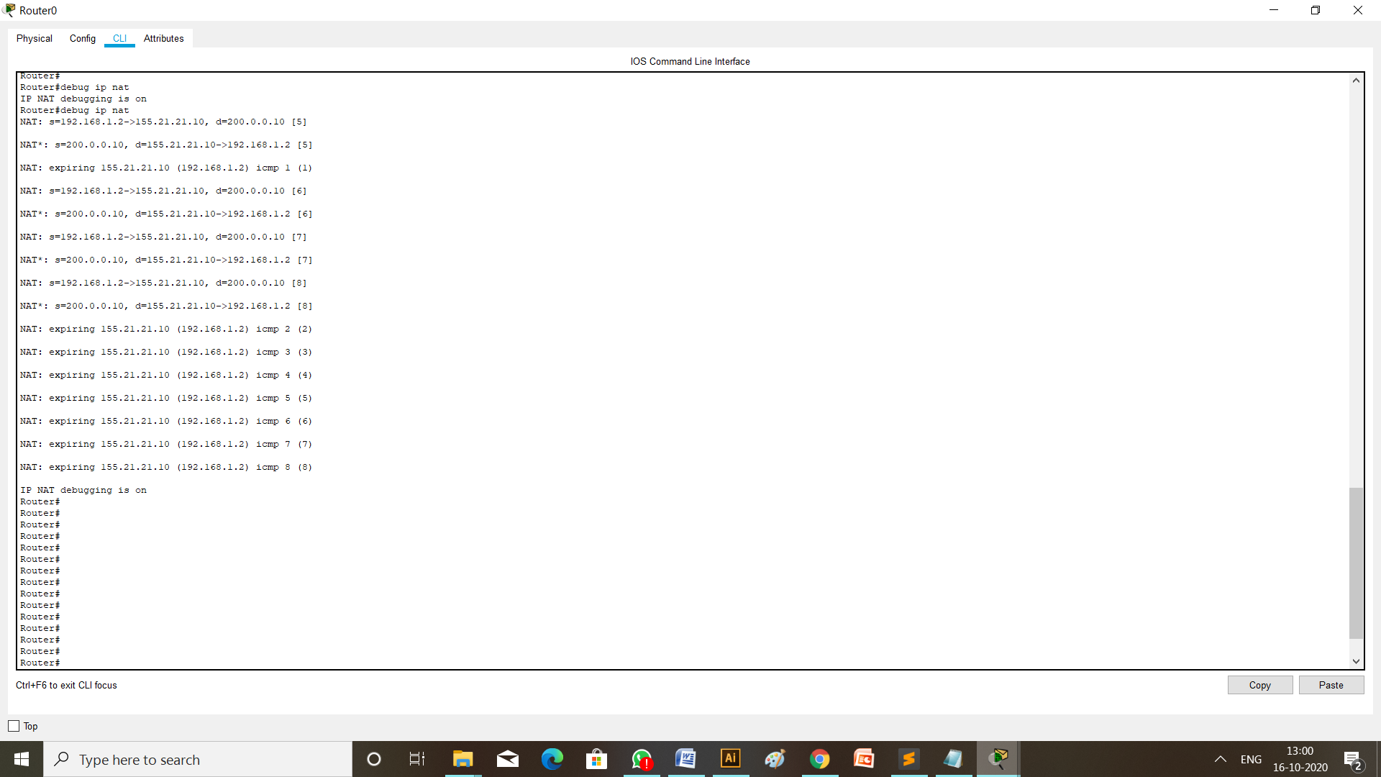

**CONCLUSION:**

Through this practical I learned about how to configure Dynamic and Static NAT (Network Address Translation) in cisco packet tracer.